Enhancing Emotional Health
And Spiritual Wellbeing

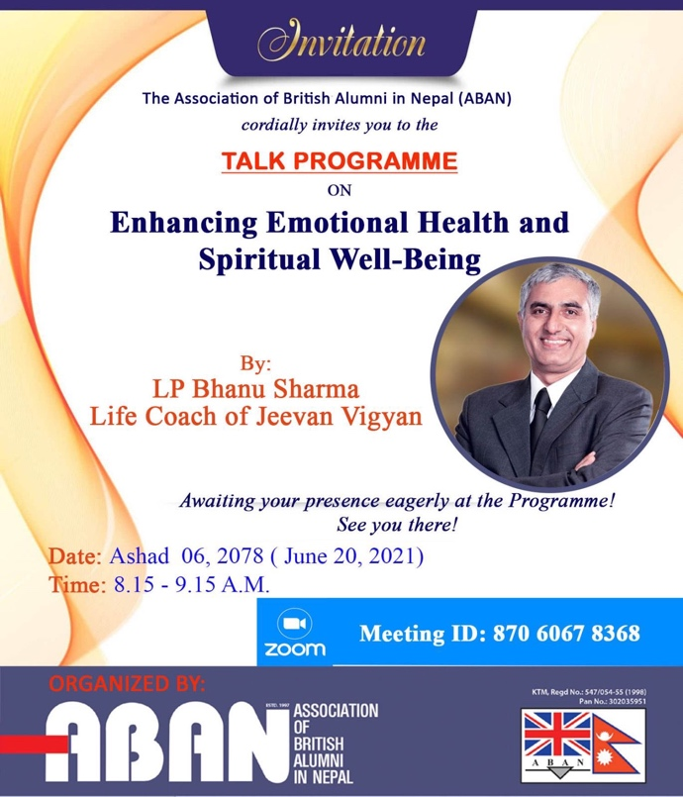
Guru L.P. Bhanu Sharma, Life Coach and Founder President of Jeevan Vigyan Foundation presented a very enlightening discourse on the topic virtually on June 20, 2021 to the members and guests of ABAN.

ABAN president Uttam Prasad Pant welcomed the distinguished guest speaker for the discourse on Spirituality on the auspicious 7th International Yoga Day of June 20, and media advisor Hari Thapa briefly introduced the guest speaker as an accomplished Spiritual Leader.

Guest speaker L.P. Bhanu Sharma thanked for the opportunity to address ABAN members and guests. He stressed on the spiritual well being through creativity. We have to live a creative life, not become the victim of situation and circumstances; and focus on present life, not repent on the past and worry about the future. Each one of us have the ability of creative choices, what we want to achieve. Creative life is an “Inside Out” process and not the other way round. We must not be the victim of circumstances, because our mind and consciousness is our identity that has the potentiality for our creative life.

We must focus on the “Content of our consciousness” and follow the path of three Yogas:
- Gyan yoga 2) Karma yoga and 3) Bhakti yoga.

“Gyana” is the thought process to determine what we want to achieve and how we want to live our life. Death is inevitable but we should plan how we live our life, quality of life. Plan your life consciously for your Spiritual health and wellbeing. Life is a creativity, ability to create happiness. We have the ability to focus on what we want to achieve despite several adverse circumstances. Focus on the present and on what we want to achieve. It is possible to achieve with our internal strength. Life is not outside it, but its inside out, being able to create a life we want to live. What is inside will manifest outside. Focus on your “content of consciousness”: ability to achieve. A bigger heart creates positive emotions.

“Karma” is to determine what and how to achieve our goal. Outline activities to achieve the objectives of life. The path to success and prosperity is through dedication, which determines our physical health and wellbeing.
“Bhakti” is the relationships we develop that determine our Leadership. Loving and compassionate emotions create Leadership. It enhances our emotional wellbeing.
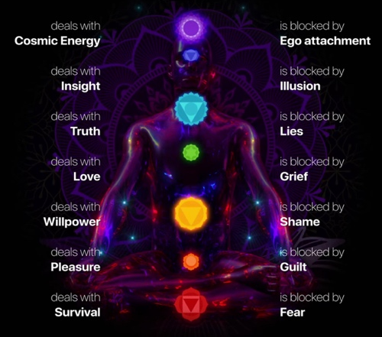
Jeevan Vigyan is an integrated, holistic and scientific approach to living. Life is a congregation of three Yogas:
- Yogabhyas, b) Pranayam and c) Dhyan / Meditation

Yoga and Aarogya is a state of wellbeing, and it originates at home, which is factory for health. Jeevan Vigyan is giving spirituality in three process:
- Chakra Vigyan to activate the seven chakras in our body,
- Self discourse (Self Communication) for extraordinary transformation in 9 days program through virtual zoom attended globally, and
- Prosperity consciousness on an Inheritance of Prosperity Model for discourse on overall prosperity.

Transcendental thought (Adhyatma) has creative ability for health and prosperity in life. We have soul which is “Power of Choice” and life is determined by this Choice, not by Chance. “I am the creator of my own creativity” and it can be enhanced by meditation: Dhyan. which is an energizer and a process to empower emotional and spiritual wellbeing.

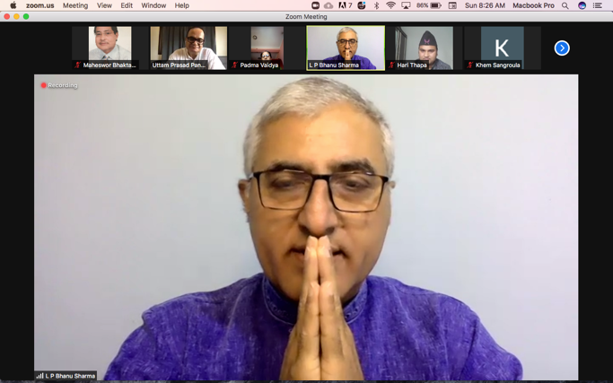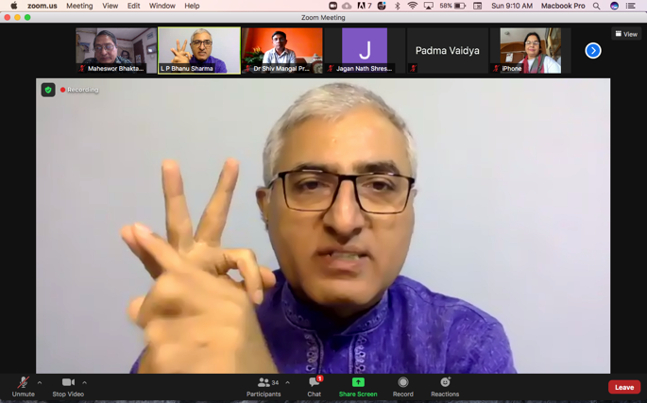

Jeevan Vigyan is a process of empowerment for spiritual/ emotional wellbeing. It is practiced in 45 countries. It helps create emotional intelligence and prosperity consciousness for an overall development in life.

Maheswor Bhakta Shrestha
June 20, 2021

